- Main information.

The game “League of Legends”(Lol) refers to “multiplayer online battle arena”(MOBA) genre.

First of all you need to choose a character, that you will take a part in a battle. A character is called a champion in this game. There are 111 different champions in game at this moment.
Players battle with each other in 4 different modes: 3x3, 5x5, dominion 5x5 and 5x5 ARAM. One mode matches to one map.

5x5-mode is the most popular. All battles of this mode take place on this map (fig. 1.1).

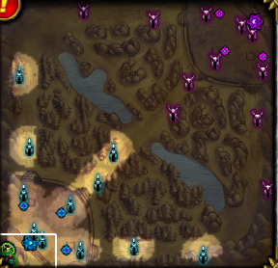
Figure 1.1. Arena for battles 5x5.

There are three lines for attack: “top”, “mid” and “bot”. There are 2 friendly towers and 1 inhibitor and 2 enemy towers and inhibitor  on each line. Enemy towers damage you and your friendly AI minions when you or someone of them close in certain range. Groups of AI minions (wave) spawn at base (nexus) every 30 seconds and moving by lines. They attack enemy champions, minions and towers when meet them on line. There are 3 fighters and 3 mages in every wave on each line. Cannons spawn in every third wave. Towers damage cannons with a less efficient. When you destroy enemy inhibitor, super minion spawns on that line.

The goal of the game: destroy enemy nexus. Minions can’t destroy enemy base by themselves, that’s why you and other 4 champion have to help them. Enemy 5 champions will be trying to destroy your base at this time.

You appear in left lower or right upper corner of the map, behind your nexus. An item shop located at that place too. You can buy necessary and helpful items in this shop. You have 475 gold at start. You can obtain gold by killing enemy minions. A champion can only carry six items at a time, making the selection of items an important part of achieving victory. Items are only obtainable through the item shop.

- Champions.

Each champion is individually designed to have unique abilities and traits that a player must use wisely. Some champions use brute strength and power, others use deadly and cunning precision, while others use supernatural vision and magic, etc. Champions generally fall into certain categories based on their skills.

A champion statistic is a number indicating how well a champion can do a certain thing. These help define the assets of a champion. There are 17 official statistics, divided into three categories: Offensive, Defensive, and Magical.

Offensive
- Armor penetration: How much the armor values of targets are reduced during physical damage calculations.
- Attack damage: Provides the initial damage value of basic attacks and scaling on some abilities.
- Attack speed: The rate at which a champion uses their basic attack.
- Critical strike chance: The percent chance that a basic attack will critically strike to deal increased damage.
- Critical strike damage: The percentage damage increase provided by critical strikes.
- Life steal: The percentage of the damage done by a champion's basic attacks that is returned to them as health.
- Movement speed: The speed at which a champion moves around the map.

Defensive
- Armor: Used to calculate the reduced damage taken from basic attacks and abilities that deal physical damage. Calculated by Armor/(Armor + 100)
- Health: The total damage a champion may take before dying.
- Health regeneration: The rate at which a champion's health is naturally restored.
- Magic resistance: Used to calculate the reduced damage taken from abilities that deal magic damage. Calculated by Magic Resist/(Magic Resist + 100)

Magical
- Ability power: Provides scaling on some abilities.
- Cooldown reduction: The percent reduction in the time after an ability is used by a champion before it can be used again.
- Magic penetration: How much the magic resistance values of targets are reduced during magic damage calculations.
- Mana: The maximum mana available to a champion for casting abilities.
- Mana regeneration: The rate at which a champion's mana is naturally restored.
- Spell vamp: The percentage of the damage done by a champion's abilities that is returned to them as health.

All champions begin the game with a certain amount of attack damage, attack speed, armor, health, health regeneration, mana, and mana regeneration. This is commonly referred to as the base value of that statistic for that champion. All champions naturally increase these stats by a certain amount every time they gain a level (except Thresh, who does not gain armor per level but instead relies on his passive). Each champion's base statistics and per-level statistics are unique and play a large role in game balance for that champion.
Two statistics that deviate from this pattern are movement speed and magic resistance. Every champion has a unique base movement speed that does not increase naturally, and every champion begins the game with exactly 30 magic resistance. Magic resistance is the only statistic that increases for some champions and not for others. In general, if a champion is ranged or has a ranged form or is classified as a tank, they will not gain magic resistance per level.
All other statistics have a natural value of zero and must be increased by other sources. The ways a champion may increase their statistics are varied and include runes, masteries, items, and auras. Some champion abilities increase that champion's statistics, either as a passive effect ( Fiora's Riposte passively increases her attack damage as well as Nasus's Soul Eater passively increases his life steal) or as an active effect ( Ryze's Desperate Power briefly increases his movement speed and spell vamp) or as an effect that follows another action ( Nocturne's Shroud of Darkness, for example, passively increases his attack speed and doubles this bonus when he absorbs a spell).

3. Runes

A rune is an enhancement that the player provides for their champion before a match on a map begins to augment the champion's abilities. Runes can only be purchased from the Riot Store with Influence Points (IP, are obtained after battles). Each rune grants a small bonus in a specific category, which stack upon each other to grant larger bonuses.

There are four kinds of Runes, with three levels each, a player can use:
- Mark: Offensive.
- Seal: Defensive.
- Glyph: Magical.
- Quintessence: Utility.
Glyphs, marks, and seals stack up to 9 for increased effect, and quintessences stack up to 3.

It is also important to note that some runes are "primary", while others are called "secondary" and provide lesser bonuses. Given a certain kind of rune, it will be primary in either marks, glyphs or seals, and secondary in the other two rune types. So, all kind of runes have one primary type for them and two secondary types. The aura shrouding a rune of a certain effect will denote which rune type it is considered primary - for example, ability power runes will have a blue aura showing that it is Glyphs that specialise in them.

4. Masteries
(По ходу прокачка мастерства и есть суть проекта)

A Mastery is an area that a player is able to focus their intense magical training into, categorized into three specific categories, which are collectively known as masteries. Some of the more advanced masteries require not only a working knowledge of previous masteries within a single category, but also the knowledge of a specific mastery. As a player gains levels of power within the League of Legends, they are able to select which specific areas of interest to focus on. Player masteries are not set in stone; based on the type of champion you wish to control in a battle arena, masteries can be changed to better suit a player 's needs, simply by pressing the "Return Points" button to completely reset your masteries and allow yourself to choose others in which to spend your points ("re-spec").

There are three types of trees that player can develop in:
- Offense Mastery
- Defense Mastery
- Utility Mastery

4.1. Offense Mastery.

It would take 38 points to fill the Offense Mastery Tree to its maximum capacity.
List of Masteries  - Double-Edged Sword  - Fury  - Sorcery  - Butcher  Requiring 4 points  - Expose Weakness  - Brute Force  - Mental Force  - Feast  Requiring 8 points  - Spell Weaving  - Martial Mastery  - Arcane Mastery  - Executioner  Requiring 12 points  - Blade Weaving  - Warlord  - Archmage  - Dangerous Game  Requiring 16 points  - Frenzy  - Devastating Strikes  - Arcane Blade  Requiring 20 points  - Havoc | 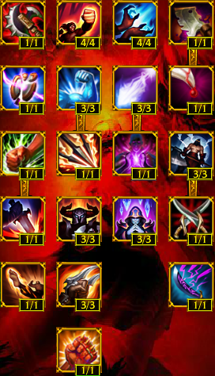

4.2. Defense Mastery.

It would take 34 points to fill the Defense Mastery Tree to its maximum capacity.

List of Masteries  - Block  - Recovery  - Enchanted Armor  - Tough Skin  Requiring 4 points  - Unyielding  - Veteran Scars  - Bladed Armor  Requiring 8 points  - Oppression  - Juggernaut  - Hardiness  - Resistance  Requiring 12 points  - Perseverance  - Swiftness  - Reinforced Armor  - Evasive  Requiring 16 points  - Second Wind  - Tenacious  - Runic Blessing  Requiring 20 points  - Legendary Guardian | 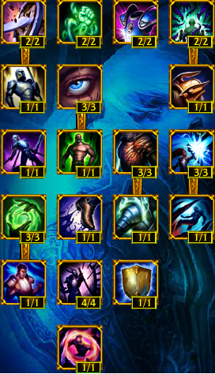

4.3. Utility Mastery.

It would take 33 points to fill the Utility Mastery Tree to its maximum capacity.
List of Masteries  - Phasewalker  - Fleet of Foot  - Meditation  - Scout  Requiring 4 points  - Summoner's Insight  - Strength of Spirit  - Alchemist  Requiring 8 points  - Greed  - Runic Affinity  - Vampirism  - Culinary Master  Requiring 12 points  - Scavenger  - Wealth  - Expanded Mind  - Inspiration  Requiring 16 points  - Bandit  - Intelligence  Requiring 20 points  - Wanderer | 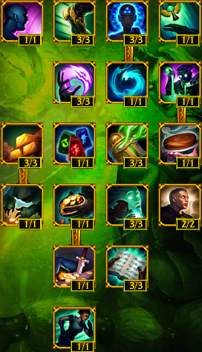

5. Items.

Items are divided into six categories: basic, advanced, legendary, mythical, consumable, and trinket. A basic item does not require any other items to be purchased. If an item requires the purchase of at least one specific basic item before it can be purchased, that item is considered an advanced item. All basic items required for the purchase of advanced items are consumed when the advanced item is purchased. The same is true for legendary items, which require the consumption of at least one advanced item, and mythical items, which require the consumption of at least one legendary item.

Consumable items are different from other item types in two ways. First, most consumable items may be stacked, allowing duplicates items to occupy the same item slot up to a cap. Secondly, consumable items may be expended to perform a specific function, permanently removing that item from the champion's inventory. On charge-based items such as the Crystalline Flask, the charge is consumable but the item cannot be stacked or consumed. Every item in the game provides some sort of effect. An item's primary effect is usually statistics, however, many items also possess secondary effects which provide champions with additional benefits beyond raw statistics. Consumables are one exception, as almost all consumables provide no benefits until consumed. In addition, some effects are labelled unique.

6. Auras.

The Aura is a passive modifier to units that are near the aura source, which may be a champion that has the aura thanks to an ability of his own or to an item he is holding, or an object, which can only be placed by a champion. Some auras buff allies, increasing their effectiveness in battle, while others debuff enemies, hindering their efforts on the battlefield. In almost all cases aura effects are unique, and cannot be stacked.

